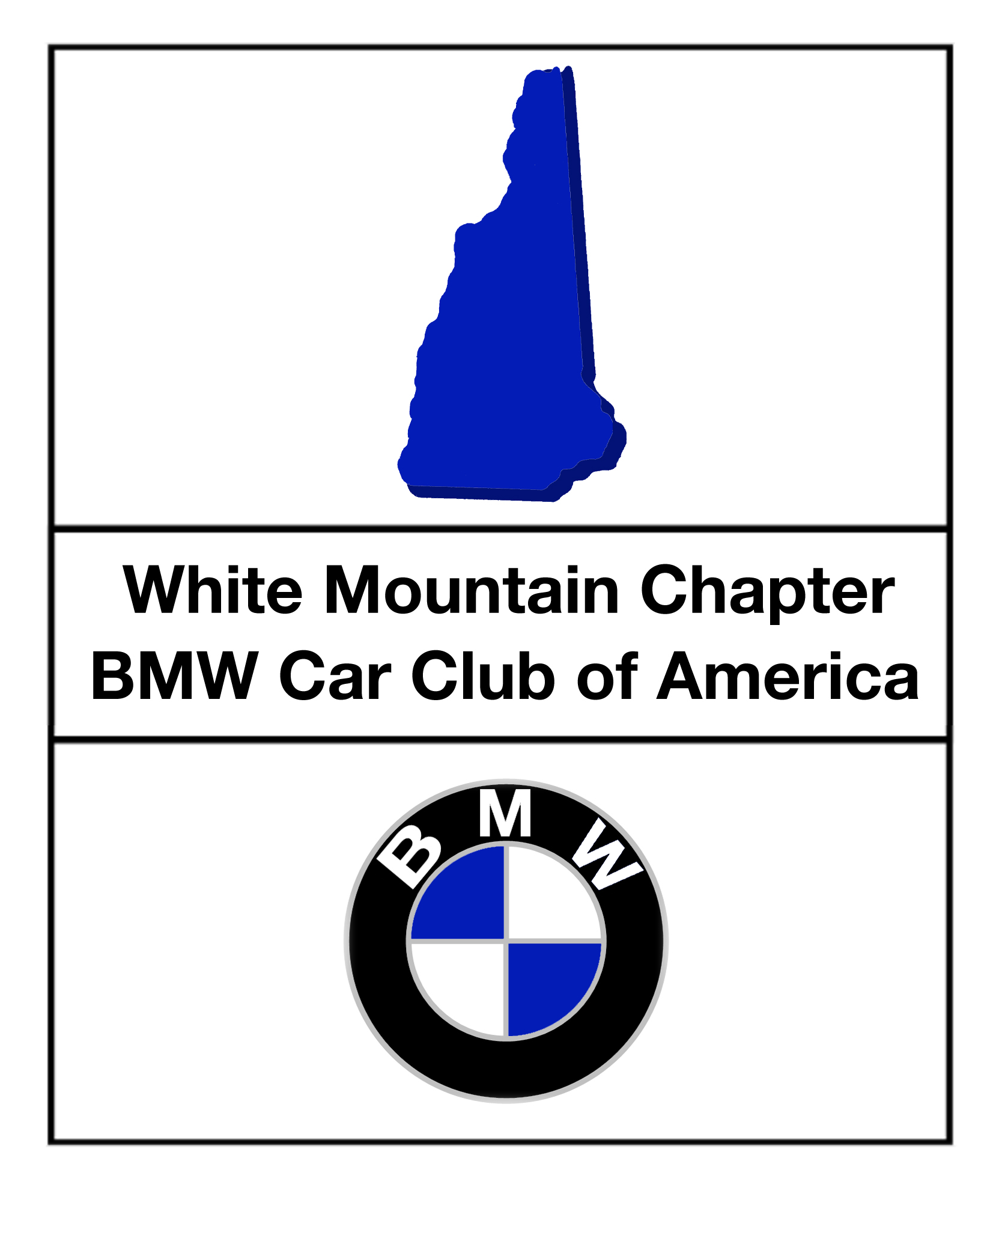

Drivers Education
Flagging Manual

30-May-03
George Bixby

Flaggers’ Responsibilities
Flaggers, or corner workers, are THE principal safety element of any track event. When you are working your assignment at a flagging station, the safety of the drivers is literally in your hands. You are responsible for assessing the condition of the track, the actions of the drivers, the severity of any incidents that occur, and, most importantly, for communicating this information to the drivers on the track and to Control.
The following information is provided for driver/corner-workers participating in White Mountain Chapter BMWCCA Drivers’ Education events. As drivers education is a non-competitive event, and, generally, the flaggers are the drivers themselves, we employ a simpler subset of the more rigorous protocols employed by professional corner workers.
Typically, two or three workers will be assigned to each corner station. One worker should operate the radio, while the other(s) man the flags.

Pay Attention
When at a flagging station, the attention of your station team MUST be focused on the section of the track from a point halfway between the previous station and your station, through to the next station. In the event that you are the only worker at a station, focus on the section from your station to the next.
Distracted, inattentive workers may be reported to the Steward by observant drivers, and these workers will be reprimanded by Control – repeated offenses will result in dismissal from the event. Cell phone use is prohibited at flagging stations, as are any other activities that divert your attention from the track.
It is necessary to listen closely to your radio. Some stations, like Start/Finish, are next to the track where loud cars are passing at full throttle, and it can be hard to hear the radio, especially without headphones.

Flags
Your means of communication with the drivers on the track is the bag of flags that you will find at the station. When not displaying a flag, keep all flags out of sight of the drivers.
The flags used at our drivers’ education events are shown in Table 1, below, along with the specific meaning of the flags for both driver and flagger.
“Standing” flags are displayed stationary with the whole flag surface shown to the drivers by holding the flag taught with both hands. Flags held with one hand may flap in the breeze and be hard to see, or be mistaken for waving flags. Under no circumstances should a displayed flag be hung on the station wall, or stuck in a pylon.
“Waving” flags are displayed by waving with a vigorous figure-8 motion, to keep the flag moving without wrapping it around the handle.
The yellow flag and the passing flag (blue with yellow diagonal stripe) should always be kept close at hand, since these are the two, and the only two, flags that may be displayed at the discretion of the flagger. All other flags will be displayed only at the direction of Control.

Safety
Each corner station will also be equipped with a fire extinguisher. If you need instruction in the use of the extinguisher, consult the Steward.

Eyes and Ears
Flaggers are the eyes and ears of Control on the track. At most tracks, Control has little or no direct visibility of most of the track, and must rely on your judgment and descriptions of conditions on the track and of cars passing your station. In your actions and assessments of corner conditions, be decisive and always err on the side of safety!
- If there is a minor incident (for example, a car spun on the track) at your station that presents any conceivable safety issue for following traffic,
  - Immediately begin waving yellow, then
  - Contact Control to describe the situation and receive further instructions.
- If there is a serious incident (for example, a car crash or rollover) at your station,
  - Immediately begin waving yellow, then
  - Contact Control and describe the situation:
    - If it appears that there is a personal injury, inform Control, and the track will be red-flagged and emergency vehicles will be dispatched to your corner. Under no circumstances display the red flag to stop traffic without specific instruction from Control.
    - If a car is disabled and cannot return to the paddock under its own power, inform Control, and, depending on the location and condition of the disabled car, the track may be black-flagged and a tow truck dispatched.
  - It is highly unlikely, but it may be necessary for the corner workers to render immediate emergency assistance, for example, if a car is on fire.
    - If there is more than one worker at the station, one must remain on station with the radio and flags.
    - If you haven’t already, apprise Control of the situation and request that all stations display red flags. Control will do so and dispatch the necessary emergency vehicles to your station.
    - Exercise utmost caution while leaving the station and traversing the track.
    - Bring the fire extinguisher with you.
    - Never expose yourself or a driver to any additional risk to “save the car.” Cars are replaceable, people are not.
    - If it is necessary to communicate the need for an ambulance back to the worker with the radio, the hand signal is both hands held together over your head, forming a letter ‘A’.
Report to Control if you observe any of the following on track:
- Cars passing without a signal;
- Cars passing outside of designated passing zones;
- Cars passing under yellow or full-course black conditions;
- Cars driving in an unsafe manner (erratically or too aggressively);
- Cars with mechanical or safety problems
  - Smoke (engine, tire, brake)
  - Leaking fluid
  - Loose wheel or bodywork
  - Loose exhaust
  - Open hoods, doors, hatches, sunroofs;
- Debris on the track;
- Fluid on the track;
- Animals (dead or soon-to-be-dead) on the track.
Before the start of each run group, Control will ask all stations to report “track clear and green.” An affirmative response indicates that your section of track is free of cars, trucks, track personnel, dirt, or debris, and that you and your team are on station and ready for cars to enter the track.

Radio Protocol
All radio dialogue should be conducted between the flagging stations and Control.
The radios have a push-to-talk (PTT) switch which enables transmission. Ensure that the switch is fully depressed before you begin speaking, and do not release it until you are finished speaking.
Keep your messages clear and concise. Identify all cars by model, color and number. Begin communication by identifying the station you are calling (Control), and then the identity of your station. Repeat the identity of your station with every transmission.
Here’s an example communication:
“Control. this is station Six.”
Wait for an acknowledgement:
“Six, this is Control – go ahead.”
Then transmit your message:
“Six is waving yellow. We have a car spun, track left, a red M3, number 2-0-3.”
Control will acknowledge your message and provide further instructions for your and, potentially other stations:
“Roger, Six, car 2-0-3, maintain waving yellow.
Five, this is Control, display standing yellow.
Control, this is Five, standing yellow.
Roger, Five. Six, this is Control, advise on car number 2-0-3 condition.
Control, Six, car 2-0-3 looks OK, under power, back on track.
Roger, Six. Go to no-flag.
Control, this is Six, no flag.
Thank you, Six. Five, this Control, go to no-flag.
This is Five, no flag.
Thank you, Five. ”
……

Special Station Instructions
There are a few stations that have responsibilities beyond basic flagging:

Start/Finish
Start/Finish manages the checkered flag at the conclusion of a session. When the session time has elapsed, Control will instruct Start/Finish to throw the checker, and to reply with the identity of the “last car.” The “last car” is the one that passes Start/Finish immediately before the checkered flag is waved – it is the last car on a hot lap in this session.
Control will then direct all stations to display standing yellow after this car has passed their station. Start/Finish has the discretion to choose a large inter-car gap in which to throw the checker, which makes the timing of this process easier on subsequent corners.

Staging
Staging is often managed by one of the Start/Finish workers. Beginning 12 – 15 minutes prior to the start of a run group, that group will be called to staging. Staged cars should line-up, angled backward, against the far wall of the staging lane, starting at the Start/Finish station. Two minutes prior to the start of the run group, the cars will be released to pit out.
It is the responsibility of the staging worker to ensure that all cars have the correct run group and inspection stickers affixed to the windshield, instructors (verify instructor wrist band) are in cars requiring them (run groups four, three, and sometimes two – check for solo stickers) and that the drivers are fully buckled-in, wearing helmets, and are ready to run before the cars are released to pit-out. The staging worker should also be on the lookout for any mechanical or safety problems (leaking fluids, smoke, tire losing pressure, abnormal noises) with the staged cars.
It may also be necessary for the staging worker to assist with pit lane traffic direction as cars in the current run group may be on pit lane for driver changes, conversations with the Steward, etc. All such stops should be conducted in the pit stalls against the near wall of pit lane, so that even when cars are staged, there is still ample clear roadway down the middle of pit lane for cars leaving and entering the track.

Pit Out
Pit Out has the additional task of releasing cars onto the track. This is a very simple process at the start of a session, when it is simply a matter of waving all the cars onto the track. Later in the session, it requires a good sense of timing to assess when a gap in the hot lap traffic will coincide with the released car entering the track. Use good judgment. Drivers should always, regardless of your confidence in the pit-out workers, carefully check your mirrors when merging onto a hot track, and, always respect the blend line.

Driver Reminders
Since you are also a driver, here are a few reminders:
- Look at all the flagging stations.
- Check your mirrors.
- Acknowledge flags.
- Obey all passing rules and zones, regardless of blue flags or point-bys.
- Two-off, four-off or spin, pit and report to steward.
- Respect the pit lane speed limit.
- In the event that your car becomes disabled on or off the track, stay in the car (unless, of course, it’s on fire), until instructed otherwise by the nearest corner station.

Table 1: Flags Explained
Flag | Driver Instruction | Flagger Instruction
Standing Yellow | The standing yellow condition indicates that there is a car, emergency vehicle, or worker in an area close to the line, or in an area where race cars may leave the course, but there is no obstruction of the line.  Standing yellow may also serve as advance warning for a waving yellow flag at the next flagging station.  Exercise caution, check your mirrors, reduce speed if necessary.  NO PASSING from the flag to past the next flag station not displaying a yellow flag. | Displayed only at the direction of Control.  All flag stations will be directed to display standing yellow during all pace/warm-up laps at the start of a session, and during the cool-down lap at the end of a session.
Waving Yellow | The waving yellow indicates that the line is partially or completely blocked by a car, cars, emergency vehicles, workers, or a combination of all of these. Drivers must be prepared to leave the line--perhaps leave the track surface or even stop--in order to avoid becoming involved in an accident.  Exercise extreme caution, check your mirrors, reduce speed.  NO PASSING from the flag to past the next flag station not displaying a yellow flag. | Displayed at the corner workers’ discretion.  If, in your judgment, there is a condition or incident on the track that creates any sort of hazard, start waving yellow immediately, then contact Control.  Remember, err on the side of safety!
Black | At any station, the black flag may be displayed and then pointed at a specific car, which indicates that there is a problem with that car or driver.  If pointed at your car, acknowledge that you have seen the flag with a nod or wave, and proceed to pit lane for consultation with the Steward.  Standing black flags displayed at all stations indicate that there is a track problem and the session is being suspended. In this case:  Exercise caution, check your mirrors, reduce speed, NO PASSING, and proceed to pit lane. If time permits, the cars may be staged and re-released onto the track when the problem is resolved. | Displayed only at the direction of Control.  Control will tell all stations (or the designated black-flag station) the description and number of the car to "black flag."  When the target car approaches, display the standing black flag, then point the handle at the car as it passes your station.  When the flag is acknowledged by the driver to a station, report to Control. Subsequent stations will no longer need to black flag the same car.  The station immediately before pit-in should report to Control when the car enters pit lane.
Red | The red flag indicates that there is an emergency on the track, and the track must be immediately cleared to permit the passing of safety vehicles.  Exercise extreme caution. Check your mirrors, and come to a stop as quickly and safely as possible at the side of the track (off line), within sight of a corner station.  The corner station will signal when it is OK to proceed, generally under full-course black flag condition. | Displayed only at the direction of Control.
Passing | The passing flag is a reminder to check your mirrors.  In the corner worker’s opinion, you are, or will soon be, overtaken by a faster car.  This flag is not a command -- you are not required to let the car pass at the next or any subsequent passing zone.  At some tracks, this flag may be waved to indicate that a car is actually in the process of overtaking you. | Displayed at the corner worker’s discretion.  As this flag is not a command, but only a suggestion, it should be used liberally, especially to help break up ‘trains’ of traffic that can form in slower run groups.  Typically, only corners immediately before legal passing zones are instructed to display this flag.
Debris | Oil, car parts, debris, or roadkill has been deposited on the track and a slippery or otherwise hazardous condition exists at this corner.  Exercise caution, check mirrors and assess the track condition at this station.  Typically, the debris flag will be displayed for one or two laps and then taken in. This does not mean that the debris or oil has been removed. It is expected that all drivers will now understand the conditions at the corner and will continue to negotiate it in a safe manner.  The debris flag redisplayed at the same corner means that a new hazard exists. | Displayed only at the direction of Control.
Meatball | The White Mountain Chapter BMWCCA does not use this flag but you may see this flag sometime in place of a regular black flag. Follow the same instructions as a black flag.  Some other clubs use this flag when there is a mechanical problem with your car.  Proceed to pit lane or the paddock for consultation with the Steward at reduced speed. If you know or suspect that you are leaking oil or another slippery fluid, drive off-line. | Displayed only at the direction of Control.
Green | The White Mountain Chapter BMWCCA does not use this flag but some other clubs use this flag when a session is under way.  The green flag indicates a clear course, as does the absence of any displayed flag. | Displayed only at Start/Finish at the direction of Control.
White | The White Mountain Chapter BMWCCA does not use this flag but some other clubs use this flag when you are approaching an ambulance, a service vehicle or a slow moving car (maybe with mechanical trouble) on the track.  Exercise caution.  At some tracks, waving white may be displayed to indicate that the slow-moving vehicle is immediately ahead. | Displayed only at the direction of Control.
Checkered | Congratulations! You have finished your session.  Complete a cool-down lap and proceed to the pit lane and paddock. | Displayed and waved only at Start/Finish at the direction of Control.

